Digital Cameras

Overview

Although digital cameras have been with us for quite a few years, they are relatively new technology.

They require no film as the image is collected by and optical-electronic process and stored on a memory chip.

There is a small computer within the camera called a micro-processor that allows the camera to do many things, including recording sound and video

Although there are dials and buttons on the camera, many of the settings are made though the cameras software and displayed on a small computer screen on the back of the camera. This screen also acts as a view-finder displaying (and also playing back) the picture to be taken

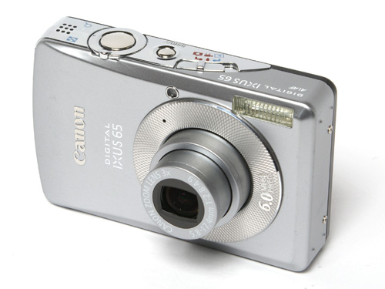

The camera can store loads of pictures, far more than can be taken with (chemical) film, and the bigger the capacity of the inserted memory chip, then the more number of good quality pictures can be stored.

Because the pictures you take are stored electronically they are instantly visible on the camera’s back screen and of course if you don’t like what you see, that picture can be instantly deleted.

Even though a very large quantity of pictures can be stored on the camera’s memory chip (e.g. anything between 750 and 2000 on a 1Gb memory chip depending on the size of pictures you decide to take) there is a limit to the number.

So most people ‘download’ the pictures onto a PC

This is done by first installing software on the PC (you only have to do this once)
Then connecting the camera with a USB cable which runs the software and copies you pictures to a folder on the hard disk drive.

You can then use the computer’s big screen to view your pictures and of course you can print them.

Because you can choose which pictures you would like to have copies of, it means that you don’t have to print the ones you don’t like.

This is just as well because although the old-style chemical film, developing and printing was costly enough, printer ink and glossy printing paper is also quite expensive.

Here are the typical items you will find in your camera’s box when you buy it

Camera strap PSU/Charger Camera Software on CD

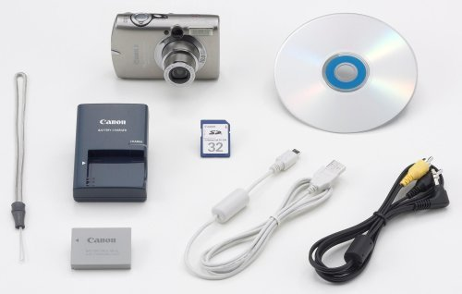

Memory chip

Battery USB cable Video cable

Charging your Camera

Your camera will come with a rechargeable battery (usually) and a power supply/charger.

This means you will not have the expense of buying batteries for your camera
But you will have to remember to charge it before you can use it.

Usually you must charge the battery up for the first time to full capacity BEFORE you use it. If you only half-charge the battery at this point, then the capacity of the battery can only ever be half of a full charge.

Also as you use rechargeable batteries, the charge capacity always diminishes, so next tiem you charge it, it will always be slightly less than the previous charge.
(So one day you may have to buy a new rechargeable battery).

The charging of the battery may take 3 – 6 hours and provide you with one or two hours of constant use. However, if you remember to switch off your camera when not using it, you will have sufficient charge for a good number of days photography.

Normally the battery may be charged without removing it from the camera and you can plug the power supply straight into a socket on the camera

Taking photographs

Usually there is a dial or series of buttons on the camera where you can switch to ‘RECORD’ mode or PLAYBACK mode.

RECORD mode is the setting you should select to take pictures, wjhere PLAYBACK is the mode required to view the pictures on your camera.

The main joy of digital cameras is that much of the adjustments to take a good photograph, happen automatically.

The camera will automatically focus on the object seen in the centre of the lens.

The camera will compensate for the amount of light available and if necessary use the integrated flash lamp to help illuminate.

There is no winding on of the film with digital cameras

Most compact digital camera’s have an optical zoom lens to magnify or zoom closer to the image which can be easily used by ‘zoom in’ and zoom out buttons.

But digital cameras also have another type of zoom called a ‘digital zoom’. This allows you to use software to ‘zoom’ into and out of the picture AFTER it has been taken!!! Usually by extreme amounts.

So really all you have to do to take a decent picture with a digital camera is to point and shoot! You can then view your picture immediately afterwards and decide if you like it or you need to take another shot.

Viewing your photographs

You need to select PLAYBACK mode to view your pictures on your camera

Usually your last shot will be displayed, but by using the left and right cursor controls you can step back and forward thru your shots to view them.

On some cameras you can also use the up and down cursor controls to electronically zoom into your pictures.

Normally with your camera you get a USB lead for connecting to a PC and a VIDEO lead which usually has a yellow phono plug on one end. This cable allows you to connect your camera to a video in (yellow) socket on a TV, then by switching the camera to PLAYBACK mode and using the left, right, up and down cursor keys you can display your pictures on TV

The USB cable is used to connect the camera to a PC so that your pictures can be downloaded and stored on the PC’s Hard Disk Drive.

Usually pictures are downloaded to a particular folder.

Inside this folder will be found other folders named by date. So when ever you download images they are categorised by date and you can see all of the pictures you downloaded on that day.

Downloading to a PC

To download your pictures, your PC must be set up first. You only have to do this once

DO NOT connect the camera to the PC yet!

Take the CD that came with your camera and insert it into the CD or DVD drive on your PC. Close the drawer and the installation will start.

Follow all instructions as they appear on screen and only when you are asked to, must you connect the USB lead to the PC (otherwise the software will not be installed properly and you will have problems!!!!)

Once the installation process has finished and you want to download some pictures, al you need to do is make sure your PC is up and running, your camera is turned on and then connect your camera to the PC using the USB cable.

The pictures will automatically be downloaded and will be copied to the download folder. You will then have the chance to view your pictures using special software that was installed from the CD or you can also view pictures using Windows Explorer.

Another way of downloading your pictures is possible (without cables) if your PC has a ‘card reader’ fitted to it. Usually these fitted card readers will allow the insertion of all types of memory chips including Sony Memory/Memory Duo/Pro sticks, Compact Flash (CF) cards, and SD/SD Mini cards.

Simply turn off your camera and remove the memory chip and insert it into the appropriate slot on your PC’s card reader. You can then use Windows Explorer to copy and view your pictures.

Pictures on your PC

Once you have your pictures on your PC you may print them and also edit them.

To print them just display the picture by double clicking on it in Windows Explorer, then when you see the picture, click the Print icon. Your picture will be printed in full colour on your printer.

The best type of paper to use for your prints is glossy photograph paper. It costs around £12 for about 15 a4 size sheets. With careful use you can print 2 or maybe 3 pictures per sheet and then cut them out.

You can also print out pictures on ordinary paper too of course.

Your pictures can also be edited once they are on your PC and this is where the fun really begins!

You can convert to any size you want to, you can crop them (knock of bits of the picture you don’t need) or zoom in. You can change colours, remove or retouch certain features of the picture and even do things like change the backgrounds or merge pictures together. You can distort pictures and add many special effects.

To do this you need image editing software like Photoshop, Photoshop Elements (cheaper) Paint shop Pro or maybe some software has already been installed from your camera’s CD.

